**WEB BASED CLOTHS ORDERING SYSTEM FOR**

**LITE FASHION STORE**

**REPORT**

**ASSIGNMENT 03**

**Version 1.0**

Prepared by

Dark Devils

KGDME Jayarathna - E2240438

GSS Lakshan - E2240402

PVMC Wickramasinghe - E2240158

**Created: 10.10.2024**

++

# Table of Contents

Table of Contents i

List of Tables iii

List of Figures iv

Chapter 01: Introduction 1

1.1 Overview 1

1.2 Background & Motivation 1

1.3 Aim and Objectives 2

1.3.1 Aim 2

1.3.2 Objectives 2

1.4 Summary 3

Chapter 02: Related Research 3

2.1 Overview 3

2.2 Introduction 3

2.2 Literature Review 3

Chapter 03: System Analysis and Design 5

2.1 Introduction 5

2.2 Requirement Analysis 6

2.2.1 Requirement Gathering Techniques 6

2.2.2 Functional Requirements 7

2.2.3 Non-Functional Requirements 9

2.3 Design Diagrams 10

2.3.1 Use Case Diagram for Full System 11

2.3.2 Use case Diagram for Customer Registration 12

2.3.3 Use case Diagram for Order Management 13

2.3.4 Activity Diagram for Admin Login 14

2.3.5 Activity Diagram for Order 15

2.3.6 Activity Diagram for Registration 16

2.3.7 Sequence Diagram for Admin Login 17

2.3.8 Sequence Diagram for Order 18

2.3.9 Sequence Diagram for Registration 19

2.3.10 Class Diagram 20

2.3.11 EER Diagram 20

Chapter 04: Technologies Adopted 22

4.1 Frontend 22

4.2 Backend 23

4.3 Database 24

4.3.1 Database Technology 25

4.3.2 Database Design Principles 25

4.3.3 Database Operations 26

4.3.4 Relational Schema 26

4.4 Additional Tools 29

Chapter 05: Implementation 30

5.1 User Interfaces 30

5.1.1 Login Interface 30

5.1.2 Products Interface 31

5.1.3 Product Details Interface 32

5.1.4 Search Option 33

5.1.5 Cart Interface 34

5.2 Addmin Interface 35

5.3 Code Snippets 35

Chapter 6: Conclusion and Future Work 35

6.1 Summary 35

6.2 Future Work 36

6.3 Contributions 37

References 37

# List of Tables

Table 1 - Use case customer management 6

Table 2 - Use case Order Management 7

# List of Figures

Figure 1 - Full system use case diagram 5

Figure 2 - Use case Diagram for Customer Registration 6

Figure 3 - Use case Diagram for Order Management 7

Figure 4 - Activity Diagram for Admin Login 8

Figure 5 - Activity Diagram for Order 9

Figure 6 - Activity Diagram for Registration 10

Figure 7 - Sequence Diagram for Admin Login 11

Figure 8 - Sequence Diagram for Order 12

Figure 9 - Sequence Diagram for Registration 13

Figure 10 - Class Diagram 14

Figure 11 - EER Diagram 15

Figure 12 - Login Interface 18

Figure 13 - Products Interface 18

Figure 14 - Product Details Interface 19

Figure 15 - Search Option 19

Figure 16 - Cart Interface 20

# Chapter 01: Introduction

## 1.1 Overview

OCSS is an all-in-one solution to give both online customers and store owners the need in abundance of today’s modern fashion retail. It is a complete platform with a good bundle of what it has to offer like user sign up, secure authentication, product browsing, cart management, order processing and real time tracking of the order. Listed as e-commerce and in-store Point of Sale (POS) system, it’s a system that caters for both online and in store customers combined to handle physical transactions and inventory.

It believes that the OCSS provides an opportunity for customers to browse through collections of clothing in categories, to make secure purchases and to follow the progress of their orders from placement until delivery. For a store owner, it has tools for inventory management, sales monitoring and report generation, which helps them learn about their performance in sales on a daily, monthly or yearly basis. The platform also has features that help manage employee data and get customer feedback to constantly improve the platform based on real user input.

The detailed documentation of system functional and non-functional requirements is described in this Report along with the way the platform operates, what the platform will develop and what the platform should be developed to. This document is meant to be a reference for everyone within the stakeholder: developers, project managers, clients, and quality assurance teams to verify that the last system complies with stated requirements.

## 1.2 Background & Motivation

The way people shop has changed drastically with the rapid evolution of e-commerce hence, convenience, accessibility, and efficiency have become keys to the success of any successful online business. In particular, the fashion industry has seen a large increase in online shopping as people choose the convenience of browsing through the collections, buying and following their orders from their houses. As this demand was growing, the Online Clothing Shopping Store (OCSS) was conceptualized as a portal between sellers and customers that effectively blurs the boundaries.

The goal of this project is to deliver an easy-to-use platform for clothing ordering where customers can simply order clothes while also providing store owners with tools for storage control, sales monitoring, and performance analysis. We developed OCSS because the need for a robust, scalable solution to the complexity of online retail business in terms of product discovery, transaction security, order management and tracking, as well as in-store business with a Point of Sale (POS) system.

As an integrated OCSS and by integrating the online and offline capabilities the solution provides the balance between the benefits for customers and benefits for store managers, which leads to operational efficiency, customer satisfaction and result in the business successful.

## 1.3 Aim and Objectives

### 1.3.1 Aim

The aim of the Online Clothing Shopping Store (OCSS) project is to build a complete e-commerce platform which offers a comfortable, simple to use shopping expertise for prospects and powerful administration instruments for store owners. The objective of this project is to allow for world class online clothing transactions that includes secure user registration, user friendly product browsing, streamlined order processing, real time order tracking and effective inventory management. The OCSS objectives will be accomplished through achieving customer satisfaction, increased operational efficiency and a competitive position in the online retail market.

### 1.3.2 Objectives

* User Experience Enhancement: Create a user-friendly interface so customers can easily look through collections, put items in their cart and make safe purchasing.
* Seamless Order Management: Helping order to run a simple and effective order process that allows real time order tracking and notifications so customers know when their order shipped from process purchase to delivery.
* Secure User Registration & Authentication: Also, implement strong user registration and authentication, secure user data and transaction safety.
* Performance Analytics & Reporting: Provide store owners with the ability to generate sales reports, how they’re performing as store employees, and create custom reports aligned with a certain set of criteria.
* Customer Engagement & Feedback: Build a feedback system that will empower customers, to share their experience and thus drive continual improvements to the platform.
* By combining these objectives, we will arrive at a full package of online and offline clothing retail system, which will not only make shopping ease but also bring the business intelligence and operational efficiency to store owners.

## 1.4 Summary

The Online Clothing Shopping Store (OCSS) is a comprehensive platform designed to streamline both online and in-store shopping experiences. It offers features like user registration, secure product browsing, cart management, order tracking, and a review system. Store owners benefit from sales tracking, and detailed reporting tools, along with a Point of Sale (POS) system for in-store transactions. OCSS enhances customer engagement through a user-friendly interface and ensures efficient order fulfillment, providing a scalable and secure solution for the fashion retail industry.

# Chapter 02: Related Research

## 2.1 Overview

This chapter explores the foundational research and analysis that inform the development of the Online Clothing Sales System (OCSS). It begins with a literature review covering advancements in e-commerce technologies, industry best practices, and critical security measures for online transactions. By analyzing the strengths and weaknesses of existing systems, the chapter lays the groundwork for identifying unique features that will set OCSS apart in the competitive e-commerce landscape.

## 2.2 Introduction

The reason for conducting the literature review is to develop a working knowledge of prior studies on e-commerce technology, applications, and security measures. The purpose of this review is to explicate various systems’ advantages and shortcomings, and prepare the reader for ideas presented in our Online Clothing Sales System (OCSS). All the practical ideas and technical solutions proposed in the course of the project are based on the results of previous researches and on the existing technologies that work for similar purposes and thus, avoid typical mistakes and fill in the gaps.

## 2.2 Literature Review

1. Existing Technologies

* Today’s e-commerce technology environment is flexible because of the changes in web development frameworks, AI, and cloud computing. Cutting-edge technologies have revolutionized user experiences and streamlined backend processes:
* Responsive Web Design: Thanks to mobile shopping, separate versions of a platform are no longer needed, as platforms use responsive design to provide the optimal experience across devices.
* AI-Powered Search and Personalization: Almost all the platforms today use artificial intelligence to make the platform smart by applying intelligence search and relevant recommendations. Collecting the information about the actions of users, machine learning helps to choose what products to display and how to improve search results.
* Progressive Web Apps (PWAs): Hybird applications which bring the features of both, web site and application, and those can be used offline as well.
* Microservices Architecture: Microservice designs become popular in e-commerce systems to enhance system scalability and maintain improvement.

1. Best Practices in E-commerce Platforms

* Successful e-commerce systems follow a set of well-established best practices aimed at maximizing user satisfaction and driving conversions:
* User-Centric Design: These include the Showily and Amazon where the number of clicks and the simple search option matches with the actual product or page with a clear unpolluted font and background.
* Seamless Checkout Processes: To help with cart abandonment some of the leading platforms use one click check out options, auto fill forms, and multiple payment options. Returning users are also signposted to help reduce the number of steps for a new user during check out.
* Omni channel Strategies: Retailers such as Wal-Mart and Target blend in-store and online and mobile commerce for a Synchromodal strategy. This way the customers will have a good impression of the channel irrespective of the shopping channel.
* Customer Support: These include; catboats and the artificial intelligence customer supports due to their contribution towards increasing the efficiency of customer service by providing instant support and sending solutions to potential everyday questions and inquiries

1. Security Measures in Online Transactions

* As more and more products and services are sold through portals on the World Wide Web, security is a key factor to protect the data of users and provide security against fraud. The following measures are standard in leading e-commerce platforms:
* Two-Factor Authentication (2FA): This adds an extra layer of security on top of the traditional password in that to successfully login to an account, a user is expected to provide an additional piece of information such as a code sent to ones phone or email address.
* PCI-DSS Compliance: Compliance with the Payment Card Industry Data Security Standard (PCI-DSS) is compulsory to any system that deals with cards. This includes the following; cardholder data encryption and transmission, as well as building secure network configurations.
* Anti-Fraud Mechanisms: AI is also used on platforms to identify and avoid fraud cases. Some of these models identify behaviour patterns such as; Unordinary spending or login patterns are also detected and blocked.
* SSL Encryption: An SSL (Secure Sockets Layer) certificates encrypt information exchanged in between users and the server and such as credit card details among other sensitive data.

1. Comparative Analysis

* To understand the competitive landscape, it is crucial to compare features available in top-tier e-commerce platforms:
* Amazon: Being a retail giant Amazon provides highly customized user experiences with especially noteworthy recommendation engine based on the machine learning. It also has a prowess in providing a good logistics and delivery system that will help in improving the satisfaction of the customer.
* eBay: eBay has also well developed its auctions and bidding processes, having a target audience in mind. It also has among the most elaborate feedback and review systems that serves to enhance buyer and seller trust.
* Shopify: Shopify is one of the leaders in the market of e-commerce solutions targeting smb; the principal features of this platform are the focus on customization, the ability to scale the store and the clearly designed interface, allowing using it even without coding knowledge.
* OCSS Differentiators: The primary differentiation of our Online Clothing Sales System (OCSS) will be based on individual tailored clothing advice, integration of an artificial intelligence powered virtual fitting room and improved real time order tracking. All these features are intended for the fashion retail segment to enhance interaction with clients and the number of sales.

.

# Chapter 03: System Analysis and Design

## 2.1 Introduction

Any software development process has system analysis and design as its backbone. In order to analyze the system requirements and design architecture of the system to meet the requirements of customer and store owners a complete approach was employed for Online Clothing Shopping Store (OCSS). In this chapter, I explore in detail how requirements were derived, how they were analyzed, and how they influenced the systems design. The collected data is the subject of the outline techniques used to collect it, it compares other systems, and the design approach that guarantees scalability, usability and security.

## 2.2 Requirement Analysis

This phase is critical stage in software development, as it identifies, collects and documents all the functional and non-functional requirements of the application. This process for the OCSS ensured alignment of the platform with user needs and business objectives. This process involved gathering comprehensive insights from these involved key stakeholders such as customers, store owners and staff. The system’s features, designs and architecture were influenced directly by the outcome of the requirement analysis phase.

### 2.2.1 Requirement Gathering Techniques

Different requirement gathering techniques were used so as to train the system about all that the requirements of system are. This allowed them to find out what functionalities, user behaviors and system constraints are needed.

* **Similar Systems**

The features and functionalities implemented in local online clothing platforms were analyzed to understand the fashion e-commerce industry in Sri Lanka. Example of these is: Fashion Bug, House of Fashions, Kandy Selection and Thilakawardhana**.** In terms of making purchase and vendor operations more efficient, these platforms provide features such as categorized product browsing, user registration, secure methods of online payment and order tracking. Each of these systems takes advantage of a combination of traditional and contemporary elements to improve customer satisfaction.

Review of these systems revealed the need for the Online Clothing Shopping Store (OCSS) to have a user-friendly interface, secure payment gateways and robust order tracking mechanisms. These insights from these platforms informed OCSS to compete locally on the market and also help provide a unique and optimized user experience.

* **Manual System Documentation**

Insights from traditional order processing, inventory tracking and customer service methods used on manual systems were gathered through a review of manual systems previously used by small garment stores. Efficiencies and bottlenecks in manual workflows like delayed feed of inventory updates and order handling issues were exposed by this documentation. In the aim to do away with these inefficiencies and automate pertinent processes such as real time stock update, order tracking and so on, OCSS digitized it.

* **Questioners**

A number of questionnaires were distributed among store owners, staff and customers to gather direct feedback from potential users. The questionnaires focused on user preferences for online shopping, preferred payment methods, feedback mechanisms and order tracking needs. The data collected helped us shape the user interface design, so it's intuitive and fits the ways that people use most often. The responses also included insights on the relevance of some elements such as secure payment gateways, personalized recommendations, the possibility to leave reviews.

* **Interviews**

We conducted interviews with key stakeholders: store managers, IT administrators and end users to get a better handle on what they expect and what exactly they are in pain. Through these one-on-one interviews we had the opportunity to delve into these items: system requirements, features and constraints in detail. Real time reporting, inventory management were mentioned as store owners stress, while customers demand a seamless shopping experience, quick order fulfillment and secure payment processing. These interviews helped in identifying the non-functional requirements i.e., system performance, security and scalability.

### 2.2.2 Functional Requirements

1. User account creation and account control

* Sign-Up Process: The new system will let users create an account with the application using their e-mail or through their social accounts like, face book or Google account. Then, an email will be sent for the validation of the created account.
* Profile Management: Registered users are able to change other particulars including name, other contact address information, and shipping and payment information. User’s profile details can be changed any time, through control panel/dashboard.
* Account Security: To make its protection even more reliable, users may apply two-factor authentication or 2FA whenever it is possible to guarantee that only those users who are allowed to enter the account can do it.

1. Product Browsing and Filtering

* Product Search: Some of the fields will allow users to enter keyword-searchable text for finding clothing (e.g., “red jacket” and “summer dress”). The search results will be shown in the form of product images, price and a short description of the product.
* Filtering Options: There will be many filter options like size, colour, price, gender, type and brand. The filters will help them narrow down the search results to their preferred option of the product in the market.
* Sorting: Customers can filter products according to their needs and preferences such as; price, rating, or even the newly listed products.

1. Cart and Checkout Process

* Cart Addition: Each product can be added to a user’s cart with a single click. The cart will update itself when an item is added and will display count and subtotal of order as well as the probable shipping charges.
* Edit Cart: Consumers will be free to amend the contents of the cart either by altering the number in each item or even deleting an item.
* Checkout Process: The checkout in the process will therefore not imply a mere point-of-sale:
  + 1. Review Cart: Still, shoppers get informed about the contents of the cart, or delete or continue.
    2. Shipping Information: Input delivery information and select the delivery option.
    3. Payment Options: Customers will be able to use their credit/debit cards, PayPal, or other integrated payment to make payments. For security, the system is going to encrypt payment information by using SSL/TLS protocols.
* Order Confirmation: Once payment is effected, the users will be posted an order number with dispatch number and an expected time of arrival.

1. Tracking of orders and the notification of the clients.

* Order Tracking: Seo users can track the stated order through their profiles as soon as they place the order. It will help to track the order’s location and time of delivery in the shortest time possible.
* Notifications: For general use the notification will be through emails and or messaging systems such as for order confirmation, shipment details for delivery details or if there was any complication during the processing. Patrons will also be allowed to set their notification priorities.

1. Admin Panel

* Product Management: The system will provide an opportunity to add, modify or delete products in the catalog for administrators only. They can modify product details, images, prices, and the item’s availability in stock.
* Order Management: From the dashboard that is intended for administrators, one will be able to see all orders made by the user; the order status, payment details, shipping details, and any comment from the user. Admins will also be able to change the status of the order that contains processed, shipped, delivered and the likes.
* User Management: From this area, admins can trace the user’s interaction with the site, interacting with complaints, or even providing refunds if needed.
* Analytics and Reports: The admin panel will offer various forms of figures and graphs, like sales, most bought products, customer distribution, traffic, etc enabling the admins come up with sound business related decisions.

### 2.2.3 Non-Functional Requirements

1. Security

Data Encryption: Any personal attribute of the user that is submitted to the system, such as payment information, will be encrypted using standard industry encryption techniques, including AES-256. All transactions will be protected with SSL certificates.

Fraud Detection: The system using machine learning techniques, to consider a particular purchasing pattern as secure or insecure, to consider an account as fraudulent. Only high risk orders can be reviewed manually.

User Privacy: It is legal for people’s information like under GDPR to be protected to avoid unauthorized use. We will anonymise or delete personal data where such request is received.

1. Performance

Optimized Load Time: The system itself will have low loading time and it will be achieved through means like compressing images, loading media only when needed, and caching of frequently accessed information.

Database Optimization: Optimised queries into the database will be employed so that other details such as products, users as well as order’s status will be retrieved in the shortest time. Such measurements like indexing standards and data normalization discussed here will enhance database efficiency and decrease the load.

Content Delivery Network (CDN): To improve downloads of static content such as images, CSS, and JavaScript a Content Delivery Network shall be used to cache content from servers close to the user.

1. Scalability

Vertical and Horizontal Scaling: Thus, the architecture of the system will allow for vertical (extension of server capabilities) and horizontal (acquisition of more servers) scaling to accommodate traffic during the peak-selling seasons, such as the Black Friday.

Cloud Infrastructure: The system will be deployed in Amazon Web Services, Microsoft Azure or similar cloud services in order to accommodate the growing user client aggregate and product portfolio.

Database Sharding: In the future, the database will be partitioned (sharded) as the platform expands in order to meet the demands of big data and maintain high availability.

1. Usability

User Interface Design: The design will consist of relatively simple aesthetics with fairly epitomized layout organization and a distinctly minimalistic interface that a user has to involve themselves into mostly merely to surf the website, shop, check out, accomplish point-of-purchase, and track orders.

Mobile Responsiveness: The platform will also be completely mobile and capable of being viewed just as well on a desktop, tablet or small smartphone screen.

Accessibility: Many aspects including accessibility for handicapped users, allowing screen reader, open with keyboard or high contrast mode, WCAG (Web Content Accessibility Guidelines) compatibility will be provided by the system.

1. Reliability

High Availability: Load balancing and fail over mechanisms will be incorporated in the system for a very high availability such that in the event of failure of a given server, the level of time required to come back online will be less.

Error Recovery: Proper error provide proper error handling mechanism will be implemented with potential solutions in the case of transactions, redirecting or broken links, etc.

Backups: This will be achieved through the following features: The system will backup as a way ensuring that no data gets lost. Data backups will be kept off-site and tested this year and annually thereafter for their ability to be restored.

## 2.3 Design Diagrams

A graphical representation of a user's potential interactions with a system is called a use case diagram. A use case diagram will frequently be accompanied by other types of diagrams and will display the various use cases and user types the system has. Either circles or ellipses are used to represent the use cases.

### 2.3.1 Use Case Diagram for Full System

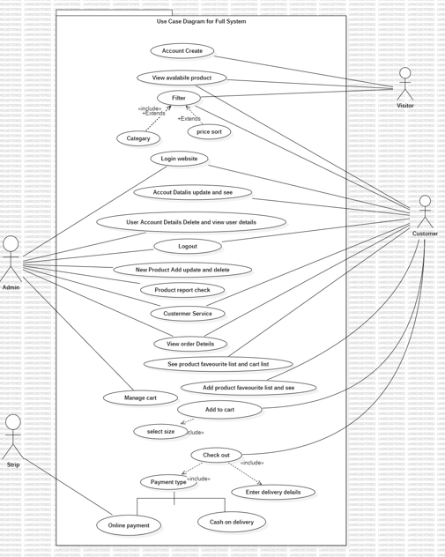

Figure 1 - Full system use case diagram

### 2.3.2 Use case Diagram for Customer Registration

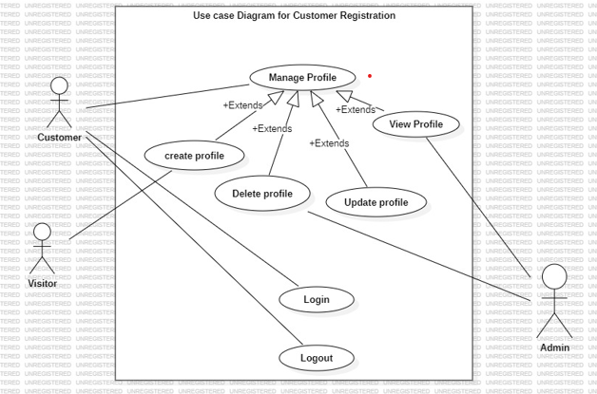

Figure 2 - Use case Diagram for Customer Registration

|  |  |
| --- | --- |
| **Use-Case Name** | **Customer Management** |
| Use-Case Type | Business |
| Use-Case ID | FO-01 |
| Requirements Priority | High Priority |
| Source | Online Form |
| Primary Business Actor | Admin |
| Other Participating Actors | Admin |
| Other Interested Stakeholders | Customer |
| Description | 1. Customer Registration  2. Customer Login  3. Customer Edit Profile  4. Customer Delete Profile  5. Customer Logout |

Table 1 - Use case customer management

### 2.3.3 Use case Diagram for Order Management

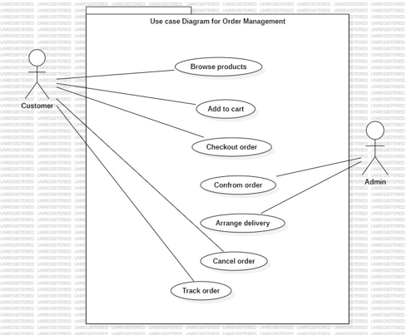

Figure 3 - Use case Diagram for Order Management

|  |  |
| --- | --- |
| **Use-Case Name** | **Order Management** |
| Use-Case Type | Business |
| Use-Case ID | FO-02 |
| Requirements Priority | High Priority |
| Source | Online Form |
| Primary Business Actor | Customer |
| Other Participating Actors |  |
| Other Interested Stakeholders |  |
| Description | 1. View product  2. Add to cart  3. Checkout order  4. Confirm order |

Table 2 - Use case Order Management

### 2.3.4 Activity Diagram for Admin Login

A class diagram in software engineering is a kind of static structure diagram that reveals the classes, attributes, operations, and relationships between objects in a system to describe the system's structure.

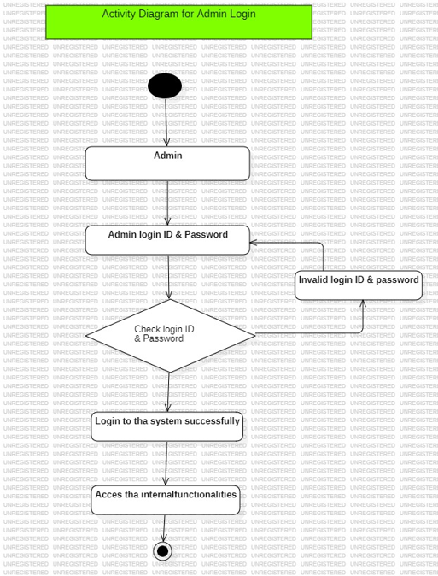

Figure 4 - Activity Diagram for Admin Login

### 2.3.5 Activity Diagram for Order

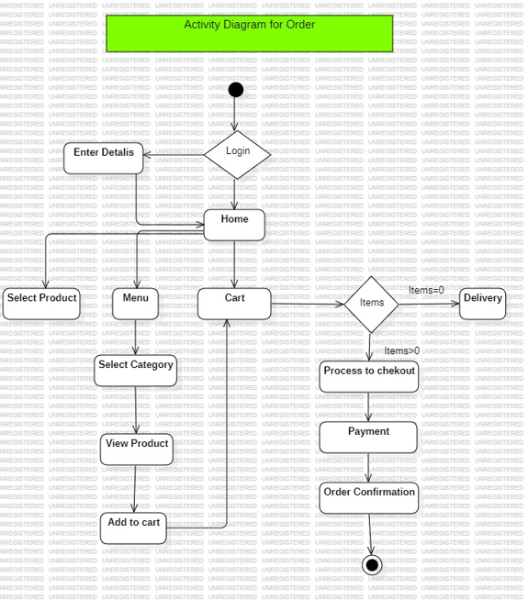

Figure 5 - Activity Diagram for Order

### 2.3.6 Activity Diagram for Registration

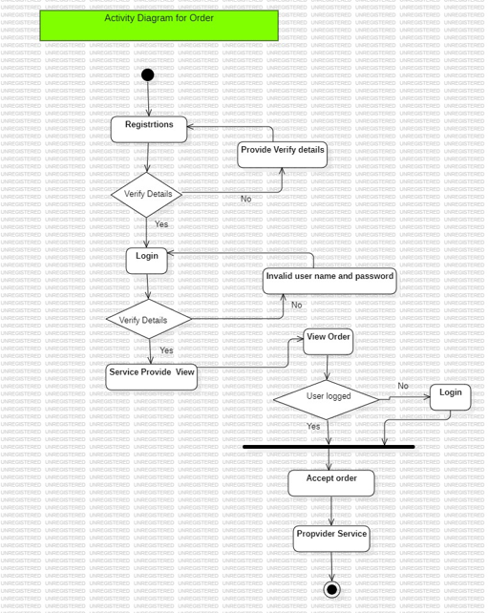

Figure 6 - Activity Diagram for Registration

### 2.3.7 Sequence Diagram for Admin Login

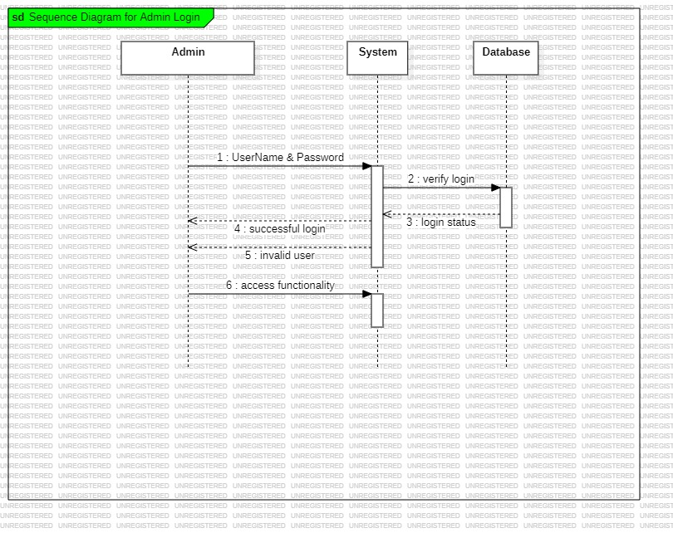

Figure 7 - Sequence Diagram for Admin Login

### 2.3.8 Sequence Diagram for Order

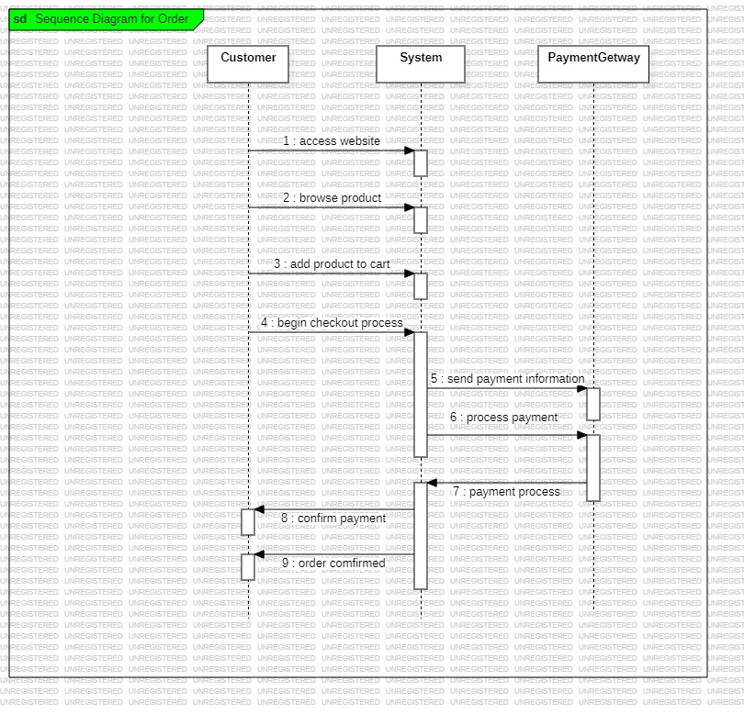

Figure 8 - Sequence Diagram for Order

### 2.3.9 Sequence Diagram for Registration

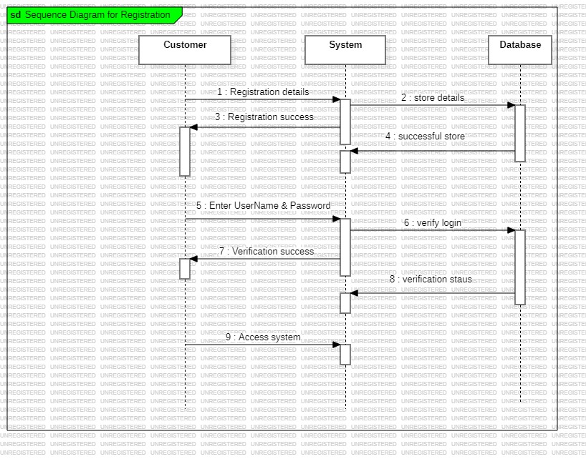

Figure 9 - Sequence Diagram for Registration

### 2.3.10 Class Diagram

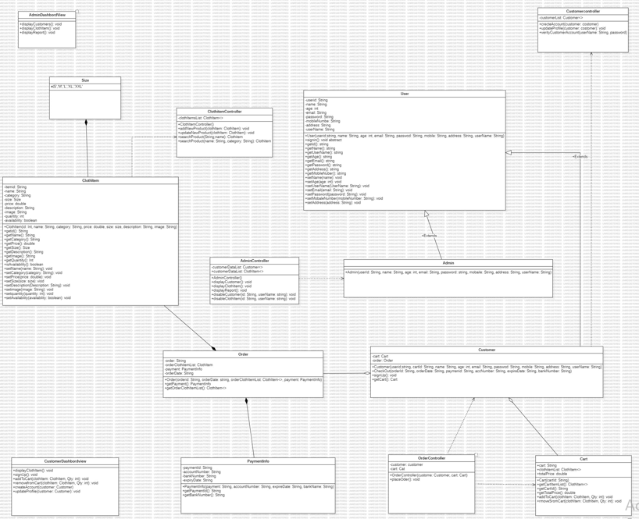

Figure 10 - Class Diagram

### 2.3.11 EER Diagram

Through high-level models and tools, EER Diagram, also known as "Enhanced Entity-Relationship Diagram" assists us in building and maintaining comprehensive databases. Additionally, they are an extended form of the fundamental ER diagrams and were created from them

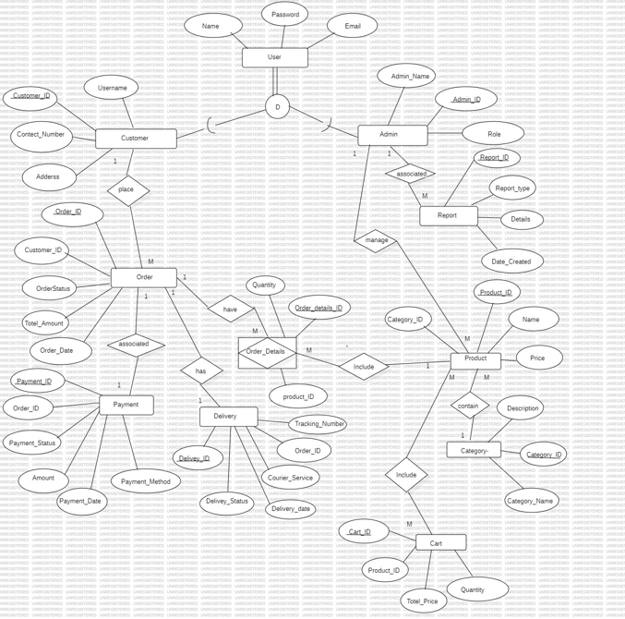

Figure 11 - EER Diagram

**EER Diagram Assumptions**

* Each clothing item belongs to only one category and one subcategory (e.g., Men, Women, Kids).
* The Customer ID uniquely identifies each customer, order, cart, payment, and shipping information.
* Customers can browse clothing items, add them to the cart, and make purchases.
* Customers can browse specific clothing items, including size and availability options.
* After placing an order, customers can track their order status and shipping information.
* Customers can pay for their orders using various payment methods (e.g., credit card, COD) at checkout.
* Only registered customers can place orders and manage their profiles, but unregistered users can browse items.
* Each customer can save multiple shipping addresses but can only select one per order.
* Orders are processed once payment is confirmed, and customers receive a confirmation email.
* Administrators can manage, update product information, and handle customer inquiries.

# Chapter 04: Technologies Adopted

## Frontend

The frontend of the Online Clothing Sales System (OCSS) is developed using dynamic and contemporary web platforms to enhance the graphical user interface. The chosen technologies make it possible to enable a consistent experience across different form factors.

Key Technologies

HTML5:

Serves as the core of the application since it interprets the meaning of the web pages. Full multimedia support (audio and video) can be incorporated with no need for additional plugins, and it supports the concepts of accessibility for various user types in a single plugin.

CSS3:

Improves the usability of the stylable widgets in the application to support better styling of the container and the widgets inside it. It supports animation, gradients, media queries, which made the layout of the website to be responsive from desktops, to tablets to mobile phones.

JavaScript Frameworks:

…………………………………………………………….

Rationale for Selection

These technologies were specifically selected based on their stability and real support, and, most importantly, high resulting quality and friendly user interface. This way OCSS strives at making a customer substantially engaged and productive in spite of the type of gadget he or she is using or the browser that he or she is keen on using.

.

## Backend

It specifically represents backend of the Online Clothing Sales System (OCSS) where every fundamental processing is performed and data is managed to maintain a smooth interaction of front end and database. These are strategic and architectural components that enable an e-commerce solution to be performance and scalability optimized and secure to meet fast changing market conditions and demand.

Key Technologies

* PHP:

The major backend language used is PHP since it is reliable, easy to learn and most importantly widely used in web applications. That is why it is perfect for OCSS since it can be used with different web servers and platforms.

Rationale for Selection

Laravel is a PHP framework selected because of its simplicity, popularity and for the frameworks ability to produce reliable and scalable applications. Its ecosystem provides features that enable developers to create applications that have fewer development time but that the backend can support more complicated e-commerce requirements such as order processing, payment integration, and users’ management.

## Database

The OCSS database is focused on the most important information which includes user details, products and orders. MySQL is chosen for managing data because it commonly recognized as reliable and scalable for the needs of the platform.

### Database Technology

MySQL is selected because it is reliable for big web-based systems and other ‘e-business’ solutions.platforms. Key reasons for selection include:

• Reliability: MySQL is a pretty stable relational database management system, which allows preventing different issues with data integrity and protection.

• ACID Compliance: Offers security and validity which is a very important factor when it comes to business especially the online business firms.

• Community Support: A wealth of vehicles and help available when things go wrong or for bringing out the best or most from the system.

• Scalability: The fact that providers can add more depth to the solutions employed as well as extent of the architectures used, to meet both increasing numbers of active users and the data traffic they generate.

### Database Design Principles

* Normalization:

Was normalized up to third normal form (3NF) to solve the problem of data redundancy and optimize storage.

Example: Transferring of users’ data as well as records of transactions into different tables that are related by foreign keys.

* Indexes:

Developed on the most used columns that include the user_id, product_id, and order_id in an attempt to optimize the queries that may be used on this table.

* Constraints:

Primary and foreign or mandatory constraints have been employed to ensure data integrity.

Some constraints introduce the ability not to have similar records (for example, distinct email addresses for users).

* Backup and Recovery:

The use of back up and recovery measures is used in order to ensure the data is safe in case of failure.

### Database Operations

* Data Retrieval: That is why efficient querying is important to organize further quick response to users’ queries and filter products if needed.
* Transactions: Every operation pertaining to the order is managed using MySQL’s transaction support leading to either atomicity, consistency, isolation, and durability (ACID).
* Scalability: Some of the features of the schema are developed to fit horizontal scaling so as to improve on the performance of the system when it is expanding.

### Relational Schema

The schema is structured to ensure data consistency, efficiency, and scalability while supporting all key functionalities of OCSS:

1. **orders**:

|  |  |  |  |  |  |  |
| --- | --- | --- | --- | --- | --- | --- |
| Order ID | User ID (foreign key) | Product ID (foreign key) | Quantity | Total Price | Payment Status | Timestamp |

1. **Order items**

|  |  |  |  |  |
| --- | --- | --- | --- | --- |
| Order Item ID | Order ID (foreign key) | Product ID (foreign key) | Quantity | Price. |

1. **User Table**

|  |  |  |
| --- | --- | --- |
| Name | Email | Password |

1. **Customer Table**

|  |  |  |  |
| --- | --- | --- | --- |
| CustomerID | Username | Address | ContactNumber |

1. **Admin Table**

|  |  |  |
| --- | --- | --- |
| AdminID | AdminName | Role |

1. **Order Table**

|  |  |  |  |  |
| --- | --- | --- | --- | --- |
| OrderID | CustomerID | OrderStatus | TotalAmount | OrderDate |

1. **Reports Table**

|  |  |  |  |
| --- | --- | --- | --- |
| ReportID | ReportType | DateCreated | Details |

1. **Products Table**

|  |  |  |  |  |
| --- | --- | --- | --- | --- |
| ProductID | ProductName | Description | Price | CategoryID |

1. **Payment Table**

|  |  |  |  |  |  |
| --- | --- | --- | --- | --- | --- |
| PaymentID | OrderID | PaymentMethod | Amount | PaymentStatus | PaymentDate |

1. **Delivery Table**

|  |  |  |  |  |  |
| --- | --- | --- | --- | --- | --- |
| DeliveryID | OrderID | CourierService | DeliveryStatus | DeliveryDate | TrackingNumber |

1. **Category Table**

|  |  |
| --- | --- |
| CategoryID | CategoryName |

1. **Order Details Table**

|  |  |  |
| --- | --- | --- |
| OrderDetailsID | ProductID | Quantity |

1. **Cart Table**

|  |  |  |  |
| --- | --- | --- | --- |
| CartID | ProductID | Quantity | TotalAmount |

**SQL Example for Schema Creation**

**CREATE TABLE users (**

**user_id INT AUTO_INCREMENT PRIMARY KEY,**

**name VARCHAR(100),**

**email VARCHAR(100) UNIQUE,**

**password VARCHAR(255),**

**phone_number VARCHAR(15),**

**address TEXT,**

**registration_date TIMESTAMP DEFAULT CURRENT_TIMESTAMP**

**);**

**CREATE TABLE products (**

**product_id INT AUTO_INCREMENT PRIMARY KEY,**

**name VARCHAR(100),**

**description TEXT,**

**category_id INT,**

**price DECIMAL(10, 2),**

**stock_quantity INT,**

**created_at TIMESTAMP DEFAULT CURRENT_TIMESTAMP,**

**updated_at TIMESTAMP DEFAULT CURRENT_TIMESTAMP ON UPDATE CURRENT_TIMESTAMP**

**);**

**CREATE TABLE orders (**

**order_id INT AUTO_INCREMENT PRIMARY KEY,**

**user_id INT,**

**order_date TIMESTAMP DEFAULT CURRENT_TIMESTAMP,**

**total_price DECIMAL(10, 2),**

**payment_status ENUM('Pending', 'Completed'),**

**delivery_status ENUM('Processing', 'Shipped', 'Delivered'),**

**FOREIGN KEY (user_id) REFERENCES users(user_id)**

**);**

**CREATE TABLE order_items (**

**order_item_id INT AUTO_INCREMENT PRIMARY KEY,**

**order_id INT,**

**product_id INT,**

**quantity INT,**

**price DECIMAL(10, 2),**

**FOREIGN KEY (order_id) REFERENCES orders(order_id),**

**FOREIGN KEY (product_id) REFERENCES products(product_id)**

**);**

**CREATE TABLE payments (**

**payment_id INT AUTO_INCREMENT PRIMARY KEY,**

**order_id INT,**

**payment_method VARCHAR(50),**

**payment_date TIMESTAMP DEFAULT CURRENT_TIMESTAMP,**

**amount DECIMAL(10, 2),**

**FOREIGN KEY (order_id) REFERENCES orders(order_id)**

**);**

**CREATE TABLE categories (**

**category_id INT AUTO_INCREMENT PRIMARY KEY,**

**name VARCHAR(100),**

**description TEXT**

**);**

## Additional Tools

To enhance functionality and ensure security, the following additional tools and integrations were utilized:

APIs:

* Payment processing solutions like the Stripe or PayPal to deal with by secure online transactions.
* Real-time tracking shipment APIs and Third-party logistics APIs.
* Recommendation engine and virtual fitting room as the features implemented via APIs and integrated with AI.

Security Measures:

* SSL/TLS Encryption: Oversees the exchange of data between the client and the server making it secure by maintaining the privacy of the data.
* Bcrypt: Employed while creating password forms in that it takes an offender many tries to guess a common user’s username and password.
* JWT (JSON Web Tokens): Useful for providing protection of authentication and subsequent session during the network communication process.

Version Control: Git and GitHub were used as repository and version for the collaboration code purposes.

Deployment Tools: Containerization was performed with the help of Docker, making environments used in development, testing, and production stages equal.

Summary

Thus, effective frontend and backend frameworks, functional and optimized database management, and additional programs for improving capabilities and security are used to create the Online Clothing Sales System design to provide customer-oriented and safe shopping. If you need more or different information let me know!

# Chapter 05: Implementation

## 5.1 User Interfaces

### Login Interface

The Login Interface which is the main point of entry into the accounts, is intended to offer an easily navigable yet secure way. This page includes:

Features:

* An input form with only two fields, either of which may contain the user’s email or username, and the other must contain the password.
* Input validation on the fly for creating proper format and completeness of entries provided by a user.
* RETRIEVAL – Account recovery tab which includes “Forgot Password” link.

Security Measures:

* Password encryption aside from the use of a simple hashing algorithm such as bcrypt.
* Additional security measures that make use of two factor authentication methods.

User Experience:

* Uncluttered design with relatively few gimmicks to prevent users from getting distracted while carrying out authentication.

As shown in Figure 12, the login interface is simplistic and effective with greater emphasis placed on the overall aesthetics of the interface and accessibility in terms of login but also security considerations.

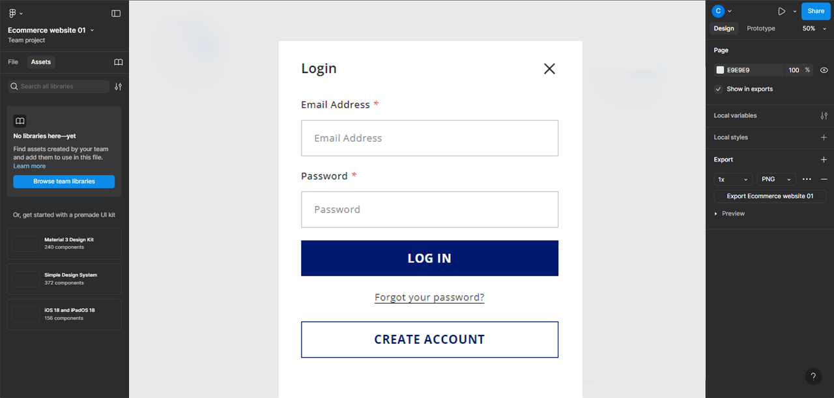

Figure 12 - Login Interface

### Products Interface

The Products Interface is the window for presenting all the items that are being sold in the online store to help the users navigate through.

Features:

* Responsive grid system that adjust the products’ placement to all devices.
* Small images of the products including the name, price, and ratings.
* Search options (such as by products in categories, price, or number of hits).
* Flashing icon for users who just want the basic details of the product without having to go to another page.

Interactivity:

* Hover effects to enhance the activistic feature of browsing.
* Implementation of Ajax for effective loading of more products.

Figure 13 illustrates the products interface aspect, and the fact that it is adaptable.

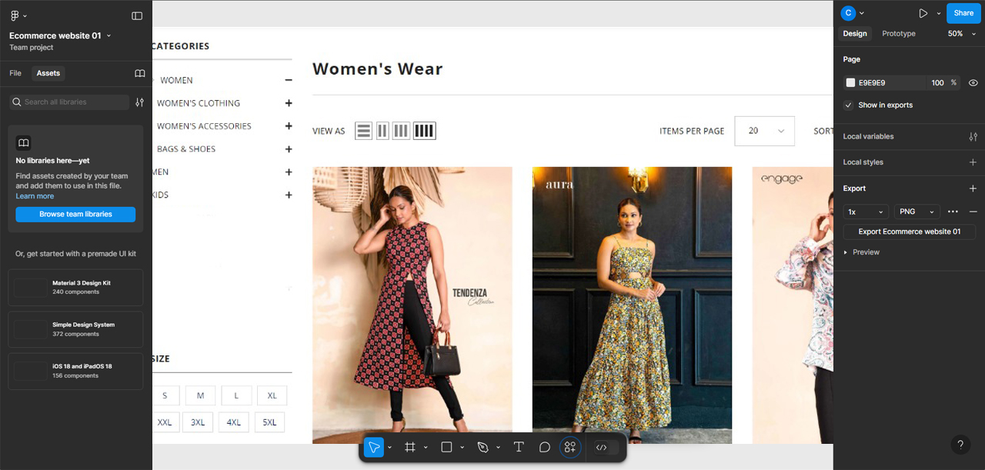

Figure 13 - Products Interface

### Product Details Interface

The Product Details Interface contains detailed information on one or several products to help make the right choice.

Features:

* Good product images that zoom in on them.
* Technical product information, such as characteristics, constituent materials, and size.
* Efficiency of options for size, color or variant choice.
* Use of customers’ feedback and rating to enable people to associate with the brand.
* For quick actions, the button is left with “Add to Cart” on it.

The pictorial view about the product details information in Figure 14 enables clients to view all details of the product at once.

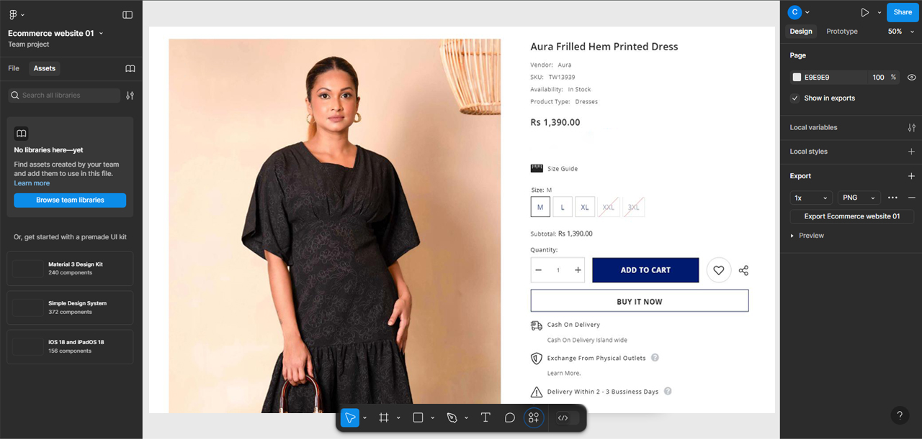

Figure 14 - Product Details Interface

### Search Option

The enhanced funct ionality of search option enables users to find specific products easily, making the usage easier.

Features:

* An auto-suggest for the search bar that will display the results immediately a user starts typing.
* Lists of sites obtained via keywords identified based upon relevance, rating, or last updated.
* Additional sub-screens for fine tuning the search results (e.g., by price or category or manufacturer).

Performance:

* So enhanced by backend algorithms for faster query responses.
* Integration of the present work with AI to include search with the use of predictions.
* This is evident in figure 15 showing the search option as been more of an intuitive and highly powerful option when it comes to the movement of users from one section of the site to the other.

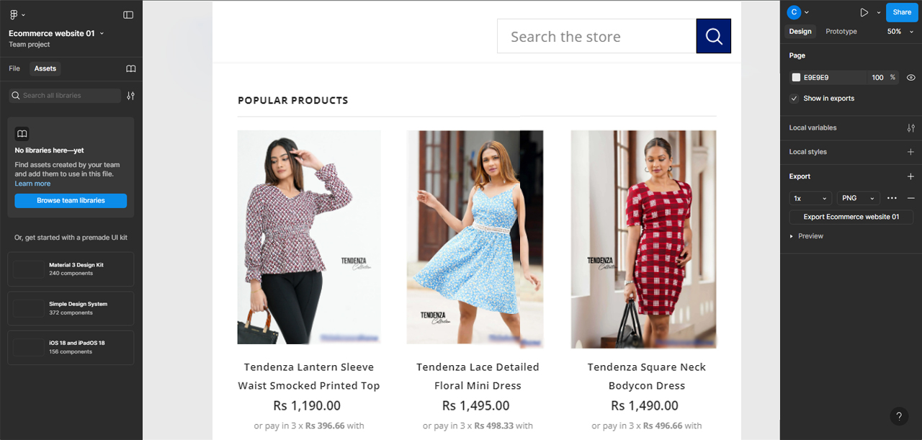

Figure 15 - Search Option

### Cart Interface

The Cart Interface is the one that offers users an option of sorting through the items selected before going for the next process of paying for them.

Features:

* All the items added will be shown including name, image, price and quantity.
* Automated computation and display of total cost when new items are added, deleted or when individual cost rates are modified.
* Still as a shopping cart, it has features of enabling one to adjust the quantities of the items or even remove such items from the cart.
* ‘Checkout’ button that leads to check out that’s where clients participate in the payment process.

User Convenience:

* It employs AJAX for display of cart details without the need for having to reload the entire page.
* Easy to identify aspects of the websites that show that discounts or some special promotions are available.
* As seen in figure 16 below, the cart interface is created with a user-friendly interface to easily managed purchases and improve the general shopping.

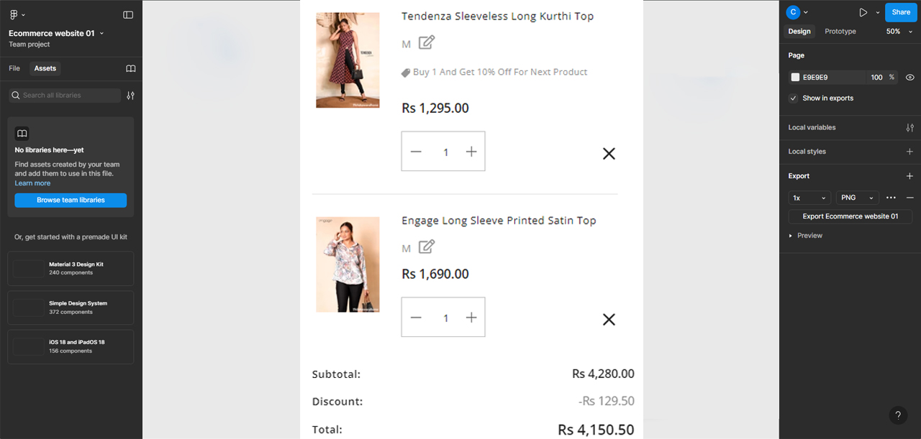

Figure 16 - Cart Interface

## Addmin Interface

## Code Snippets

# Chapter 6: Conclusion and Future Work

## 6.1 Summary

The Online Clothing Sales System (OCSS) project was designed to address inadequacies of current fashion retail business models and develop an efficient, easy to use online retail system. This system incorporated advanced technologies and practices thus providing efficient security together with customers’ interaction during shopping. Key accomplishments include:

* Designing the frontend of an application or website that is easy to navigate for the peculiar users.
* As you know, backend development is about programming the application’s inner necessary capabilities and making possible add-ons such as order tracking and secure payment.
* Implementing a most suitable normalized ER model for the creation of relations, tables and attributes to store and manipulate user, product, and transaction details.
* Making certain that security is comprehensive in encrypting data, checking out the authenticity of the data and protocols that applied security standards.
* Constructing specific value-added components such as an implementation of an ocular artificial intelligent virtual fitting room, extolling OCSS as distinct from rivals.

The project was able to show that technology can be implemented to improve the customer experience in the field of e-commerce.

## 6.2 Future Work

While the current iteration of OCSS fulfills its primary objectives, there are several opportunities for further enhancement and expansion:

Integration of Advanced AI Features:

* Extend recommendation methods using machine learning approaches for users’ activity analysis.
* Extend the current application of virtual fitting room with augmented reality (AR) technology to make the fitting as real as possible.

Mobile Application Development:

* Increase the audience by developing specific mobile applications for Android and iOS operating systems.

Global Market Expansion:

* Extend the system to cover support for multiple languages and multiple currencies in view of global markets.

Advanced Analytics:

* To enhance the outcome of the complex sales strategies, it is highly advisable to introduce business intelligence tools to profoundly analyze the major peculiarities of sale’s performance and future tendencies.

Blockchain Integration:

* Adopt blockchain to enable secure payment methods as well as to overhaul transparency in tracking products.

Sustainability Features:

* Supplement by integrating environment friendly tools like carbon footprint of products and promote sustainable choice.

## 6.3 Contributions

The OCSS project contributes to both the academic and professional realms in several significant ways:

Technical Contributions:

* Shows how modern Web technologies, backend frameworks, and database systems can be utilized in the creation of a large-scale e-business system.
* Includes new features such as an AI fitting room and list of inspiring recommendations for further use challenging the user experience.

Business Value:

* Serves as an effective, customer-oriented solution focusing on outline issues in online clothing selling, including order processing and user engagement.
* Helps the further development of the segment of fashion retail trade by offering small companies to use progressive e-commerce platforms.

Educational Impact:

* Being a sample application, it is the perfect learning resource for learning about the development of a contemporary e-business solution from design to implementation.

In conclusion I will say that OCSS has set the ground for the kind of change that the online retail industry. Because it confronts current difficulties and successfully assimilates future possibilities, it is ripe for prolonged stability and creativity.

# References

[1] “Depop - Buy, Sell, Discover Unique Fashion.” Accessed August 27, 2024. https://www.depop.com/

[2] “Fashion Bug | Online Dress Shopping in Sri Lanka.” Accessed August 27, 2024. https://www.fashionbug.lk/

[3] “GFLOCK Clothing Sri Lanka.” Accessed August 27, 2024. https://gflock.lk/

[4] “House of Fashions Sri Lanka.” Accessed August 27, 2024. https://houseoffashions.lk/ [5] “Kandy Selection.” Accessed August 27, 2024. https://kandyselection.lk/

[6] NOLIMIT. “Home.” Accessed August 27, 2024. https://www.nolimit.lk/

[7] “Poshmark: Buy and Sell Fashion, Home Decor, Beauty & More.” Accessed August 27, 2024. https://poshmark.com/

[8] “Shop Women’s Clothing, Footwear & Accessories Online | Nils Store.” Accessed August 27, 2024. https://nilsonline.lk/

[9] “Thilakawardhana | Online Store.” Accessed August 27, 2024. https://thilakawardhana.com/

[10] “Vinted | Sell and Buy Clothes, Shoes and Accessories.” Accessed August 27, 2024. https://www.vinted.com/